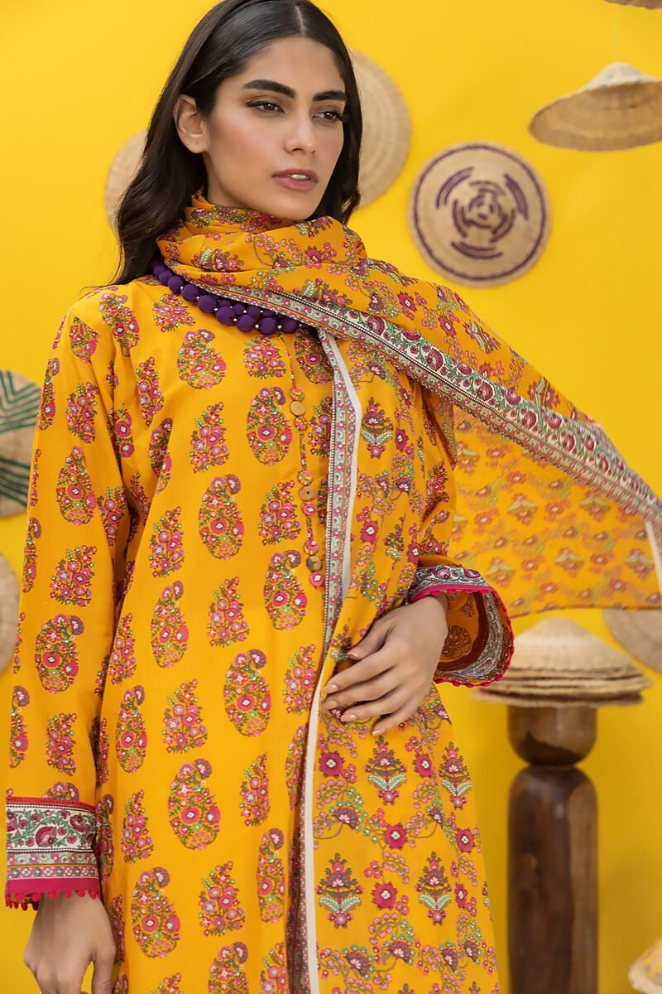

They are typically made from the same fabric as the shirt, creating a cohesive and harmonious look. The shalwar is designed to provide comfort and modesty while allowing freedom of movement.

To complete the ensemble, a matching or contrasting dupatta (scarf) can be added. The dupatta adds a graceful and traditional touch to the outfit. It can be draped over the shoulders or wrapped around the neck, depending on personal preference and style.

* **Details**
  + **Top Fabric:** Dyed Dobby | 3.25m
  + **Bottom Fabric:** Dyed Dobby | 2.5m
  + **Dupatta Fabric:** Digital Printed Cotton Square | 2.5m
  + **Campaign:** The Print Story